The Roseau County Soil and Water Conservation District

About our District
Since 1956, the Roseau County Soil and Water Conservation District (SWCD) has served the community by coordinating technical and financial assistance for local landowners.

Our mission
The purpose of the Roseau SWCD is to assist land users in applying proper conservation practices to soil and water resources. Our SWCD is a local unit of government established under state law to carry out conservation programs at the local level. Our district works with landowners to help them manage and protect land and water resources on all private lands.

Our board
Our five-member, locally elected Board of Supervisors set policies, provide local input and insure oversight and accountability for the district. The SWCD Board meets the second Tuesday at 7:00 am of each month.

Our partnerships

Our SWCD works closely with various organizations and agencies to meet the conservation needs of the local landowners. Our primary partners include the USDA Natural Resources Conservation Service, Farm Service Agency, Roseau County and the Minnesota Board of Water and Soil Resources. Together we are able to leverage local, state and federal resources to put conservation practices on the landscape.

Education is a key to our programs. 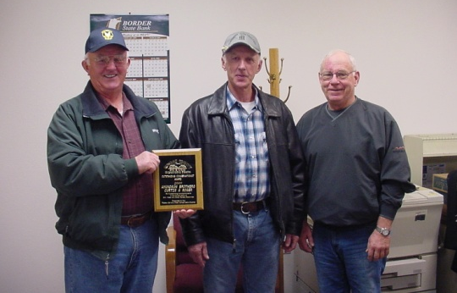

Our assistance

Many of the private landowners who invest their own money in conservation practices appreciate being able to put a face to the people helping them care for their land and water. The Roseau SWCD office is the place to ask questions about all phases of conservation, from improving water quality to forestry assistance to establishing wildlife habitat.

Our critical work

Among other things, our district helps:
- provide technical expertise to landowners to identify, apply for, and participate in local, state and federal conservation programs;
- implement farm, urban, lake and forestland conservation practices to protect water quality, soil productivity, and wildlife habitat;
- restore and protect wetlands, which purify water and provide wildlife habitat;
- assist homeowners and communities to plant trees and other vegetation to hold soil in place, clean the air, provide cover for wildlife and beautify neighborhoods;
- guide developers in controlling soil erosion and protecting water resources during construction; and
- reach out to communities and schools to teach the value of natural resources and encourage conservation efforts.

Contact us

Our office is open Monday through Friday from 8:00 a.m. until 4:30 p.m., except for holidays. We are located at 502 7th St SW, Ste 8, Roseau, MN. Reach us by phone at (218) 463.1903 or visit our website www.roseauswcd.org.

